**The NEED Statement**

(USER) needs a way to (THE NEED) because (THE INSIGHT)

*Who, What, Where, When, Why… But* ***NOT*** *How*

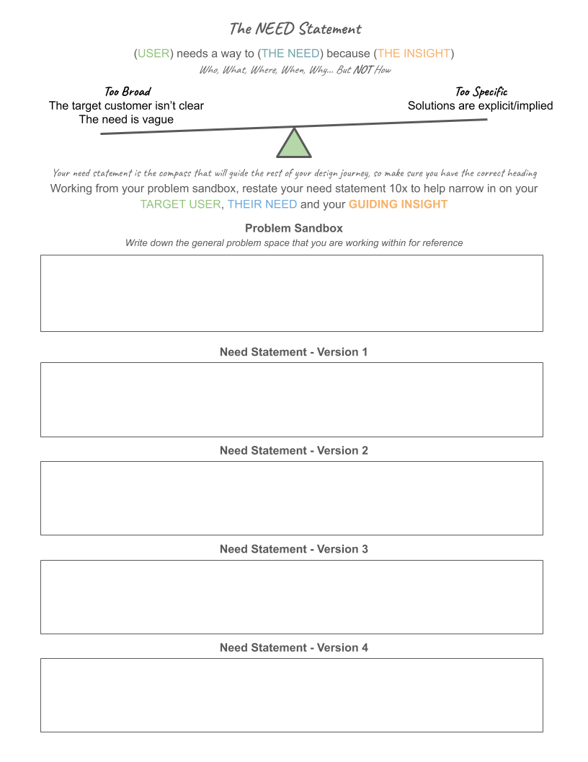

Your need statement is the compass that will guide the rest of your design journey, so make sure you have the correct heading

Progressively revise and restate your need statement 10x to help narrow in on your **TARGET USER**, **THEIR NEED** and your **GUIDING INSIGHT**

**Need Statement - Version 1**

|  |
| --- |
| The NCC needs a way to have a scalable design because the NCC might want to build similar hides in other places. |

**Need Statement - Version 2**

|  |
| --- |
| **The NCC** needs a way to **allow people to observe the wildlife** because **it can give visitors positive experiences with the nature** |

**Need Statement - Version 3**

|  |
| --- |
| **The NCC** needs a way to **have a hide which blends into the environment** because they do not want it to be seen as "a blot on the landscape". |

**Need Statement - Version 4**

|  |
| --- |
| **The NCC** needs a way to **create a nature hide capable of holding 4-8 people and wheelchair accessible** because **the NCC is run off donations, and by more people having positive experiences in nature they are more likely to donate to the NCC.** |

**Need Statement - Version 5**

|  |
| --- |
| **The Nature Conservancy of Canada (NCC)** needs a way **to create a nature hide capable of holding 4-8 people and wheelchair accessible**  because **the NCC wants a way for all kinds of people who visit Peelee Island to be able to experience nature without disturbing it as well as improving relations with their donors.** |

**Need Statement - Version 6**

|  |
| --- |
|  |

**Need Statement - Version 7**

|  |
| --- |
| **The Nature Conservancy of Canada (NCC)** needs a way **to create a nature hide that blends in seamlessly with the surroundings which is capable of holding 4-8 people and is wheelchair accessible** because **the NCC wants a way for all the visitors of Peelee Island to be able to experience nature without disturbing it or detracting from the natural beauty along with improving relations with their donors.** |

**Need Statement - Version 8**

|  |
| --- |
|  |

**Need Statement - Version 9**

|  |
| --- |
|  |

**Need Statement - Version 10**

|  |
| --- |
|  |

**------**

**Keep Your Need Statement With You As You Innovate**

Your need statement will evolve continuously as you investigate the problem sandbox. Don’t be afraid to revisit it when you uncover information that seems to dispute, or even confirm it.

**Good design is founded in understanding the problem well**

Most ‘needs’ and ‘problems’ we see are the symptoms of deeper, true, needs. By uncovering the real need, you are able to innovate meaningful solutions.

**------**

**NEED Statement Specificity Example**

**Example Problem**

|  |
| --- |
| A significant number of patients with open wounds often have lasting conditions when the wounds fail to heal; even after debridement procedures. Existing solutions are not effective. Is there a way we can improve the healing process? [*Debridement* is a procedure for treating a wound in the skin. https://surgery.ucsf.edu] |

**------**

**Need Statement - Version 1**

|  |
| --- |
| A way to improve the healing of wounds in patients after a debridement procedure |

**Considerations:** WHO are the patients? Elderly? Diabetic? Get specific…

WHAT type of wounds? Can we be more specific so we target the right procedures

**Need Statement - Version 3**

|  |
| --- |
| A way to improve the healing of **ischemic wounds** (restricted blood flow) in **elderly diabetic patients** after a debridement procedure |

**Considerations:** WHERE will our innovation be used?

**Need Statement - Version 6**

|  |
| --- |
| A way to improve the healing of ischemic wounds in elderly diabetic patients after a debridement procedure **in a patient’s home after discharge from hospital** |

**Considerations:** WHO else has to be involved… *etc.*

*What is the insight?*

*Can we be more specific about what we want?*

**Need Statement - Version 10**

|  |
| --- |
| **A way to improve the healing of ischemic wounds to a grade 1 or better** in **elderly diabetic patients** after a debridement procedure by a **visiting nurse** in a patient’s home after discharge from hospital  Because…  **there are no easily accessible effective ischemic wound healing mechanisms/devices, which results in the healing of failed wounds even after debridement procedures** |

**Make sure you have:**

**TARGET USER** | **THEIR NEED** | **A GUIDING INSIGHT**